Milestone 2 — ERD Design & Normalization
Faizan Haider and Maaz Khan

First Normal Form (1NF)
users Table

The users table already satisfies 1NF because all attributes contain atomic values and there are no repeating groups or multi-valued fields. Each column stores only one value for each record. No changes were required.

categories Table

The categories table already satisfies 1NF because every attribute stores a single value only. There are no duplicate groups or multiple values in a single column. No changes were required.

organizers Table

The organizers table already satisfies 1NF because all fields are atomic and each record represents a single organizer entity. No repeating attributes exist. No changes were required.

events Table

The events table already satisfies 1NF because every attribute contains only single atomic values such as one venue, one date, and one time per event. No multi-valued attributes are present. No changes were required.

bookings Table

The bookings table already satisfies 1NF because each booking record stores one booking transaction with atomic values only. There are no repeating groups or arrays. No changes were required.

feedback Table

The feedback table already satisfies 1NF because each field stores only one value and each record represents a single feedback entry. No changes were required.

Second Normal Form (2NF)
users Table

The users table satisfies 2NF because it uses a single-column primary key (user_id). All non-key attributes such as name, email, and role depend completely on the primary key. No partial dependency exists. No changes were required.

categories Table

The categories table satisfies 2NF because all non-key attributes fully depend on the single primary key (category_id). No partial dependencies exist. No changes were required.

organizers Table

The organizers table satisfies 2NF because every non-key attribute depends entirely on organizer_id. Since the table uses a single-column primary key, partial dependency is impossible. No changes were required.

events Table

The events table satisfies 2NF because all attributes such as event_name, venue, event_date, and status depend fully on event_id. There are no composite primary keys causing partial dependency. No changes were required.

bookings Table

The bookings table satisfies 2NF because all attributes depend completely on booking_id. Information about users and events is stored separately through foreign keys instead of duplication. No changes were required.

feedback Table

The feedback table satisfies 2NF because all non-key attributes such as rating and comment depend fully on feedback_id. No partial dependency exists. No changes were required.

Third Normal Form (3NF)
users Table

The users table satisfies 3NF because there are no transitive dependencies. Non-key attributes such as name, email, and role depend only on the primary key (user_id) and not on other non-key attributes. No changes were required.

categories Table

The categories table satisfies 3NF because all non-key attributes depend only on category_id. There are no indirect dependencies between non-key attributes. No changes were required.

organizers Table

The organizers table satisfies 3NF because organizer information is stored independently and all attributes depend directly on organizer_id. No transitive dependency exists. No changes were required.

events Table

The events table satisfies 3NF because category and organizer details are separated into their own tables using foreign keys. Event attributes depend only on event_id and not on other non-key attributes. This separation removed transitive dependency and improved normalization. No further changes were required.

bookings Table

The bookings table satisfies 3NF because booking details depend only on booking_id. User and event information are referenced using foreign keys rather than storing duplicate data inside the table. No transitive dependency exists. No changes were required.

feedback Table

The feedback table satisfies 3NF because rating and comment depend only on feedback_id. Event and user information are stored in separate tables and linked through foreign keys, removing transitive dependency. No changes were required.

--------------------------------------------------------------------------------------------------------------------

Step 2 — Remove Duplicates
users Table

The users table was checked for redundant or overlapping attributes. No duplicate columns were found. The email field was kept unique to prevent repeated user records. No changes were required.

categories Table

The categories table was reviewed for repeated category information. Since event categories are stored separately and referenced through category_id in the events table, duplicate category names inside the events table were avoided. No changes were required.

organizers Table

The organizers table was checked for overlapping organizer information. Organizer details are stored only once and referenced by the events table using organizer_id. This design prevents duplication of organizer data across multiple events. No changes were required.

events Table

The events table was reviewed for redundant data. Category and organizer information are not stored directly in the table; instead, foreign keys (category_id and organizer_id) are used. This prevents repeated storage of category names and organizer details for every event. No changes were required.

bookings Table

The bookings table was checked for repeated user and event information. Instead of storing usernames, emails, or event details repeatedly, the table references users and events through foreign keys (user_id and event_id). This removed duplicate data and maintained consistency. No changes were required.

feedback Table

The feedback table was reviewed for redundant attributes. User and event information are linked through foreign keys rather than storing repeated names or event details inside the table. This prevents duplicate data storage. No changes were required.

Summary of Duplicate Removal

The database schema was already designed to minimize redundancy through normalization and the use of foreign keys. Duplicate information such as category names, organizer details, user information, and event details was avoided by separating entities into individual tables and linking them through relationships. Therefore, no major restructuring or column removal was necessary.
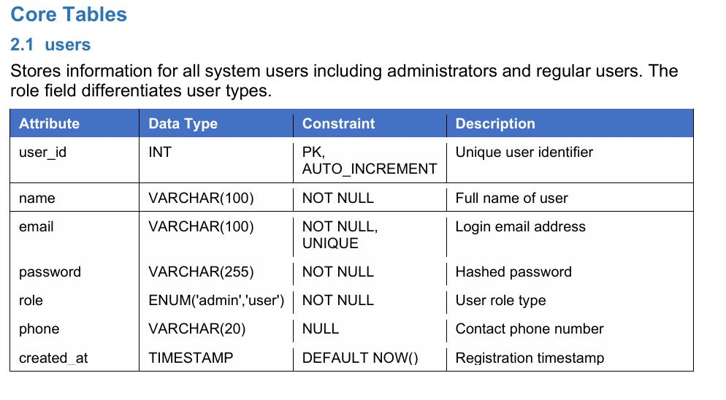

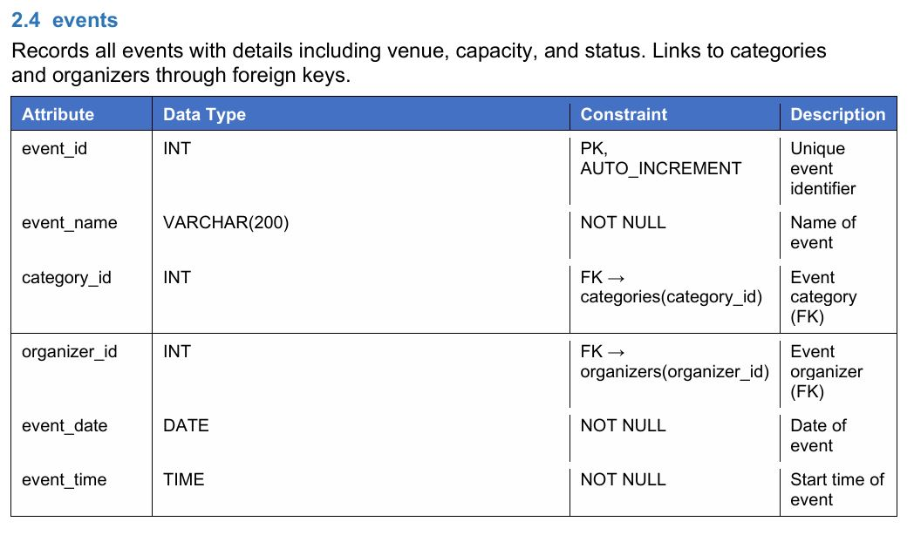

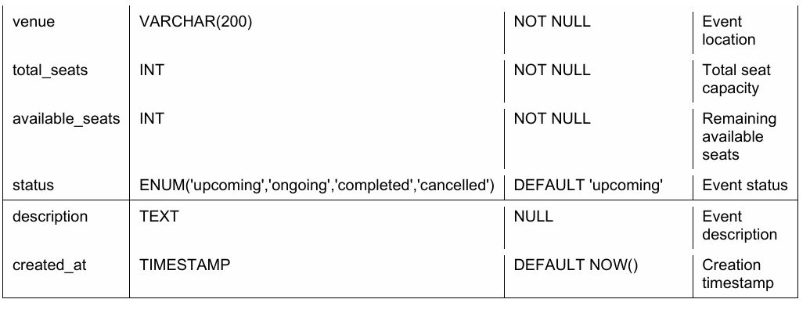
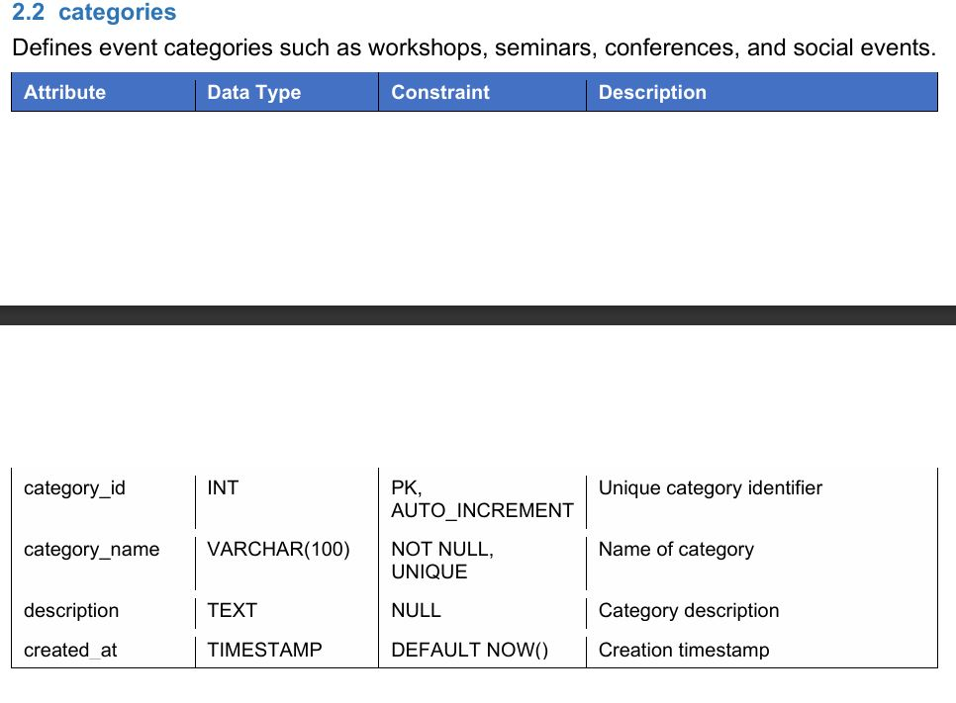
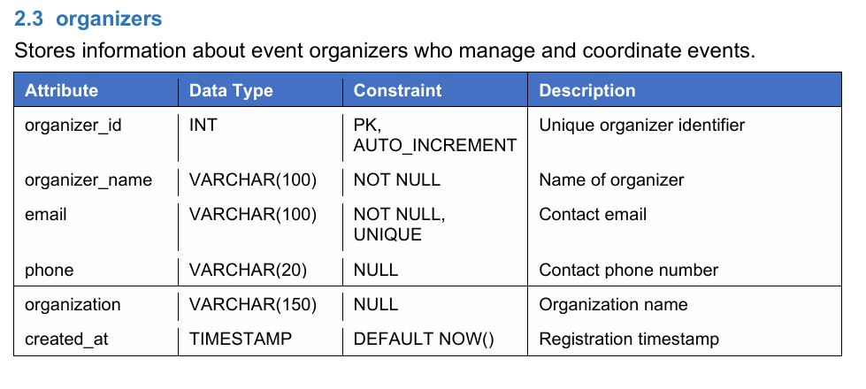
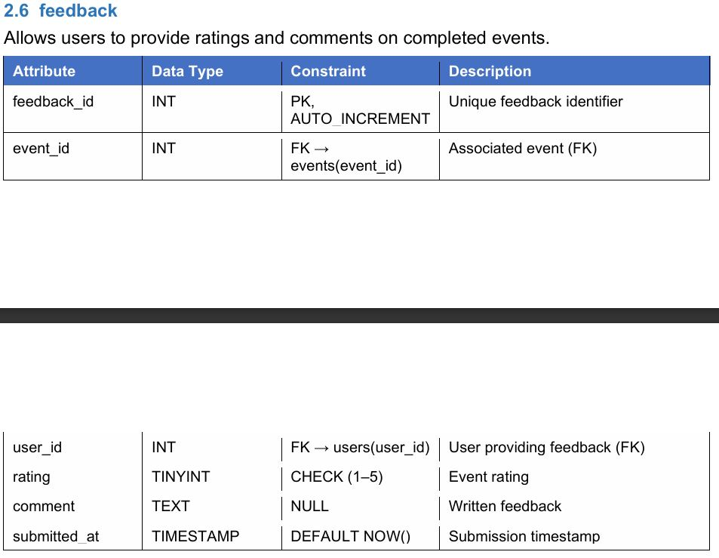
Relationships and Cardinalities
users → bookings

Relationship Type:

One-to-Many (1:N)

Description:

One user can make many bookings.
Each booking belongs to one user.
events → bookings

Relationship Type:

One-to-Many (1:N)

Description:

One event can have many bookings.
Each booking belongs to one event.
categories → events

Relationship Type:

One-to-Many (1:N)

Description:

One category can contain many events.
Each event belongs to one category.
organizers → events

Relationship Type:

One-to-Many (1:N)

Description:

One organizer can manage many events.
Each event is managed by one organizer.
users → feedback

Relationship Type:

One-to-Many (1:N)

Description:

One user can submit multiple feedback entries.
Each feedback entry belongs to one user.
events → feedback

Relationship Type:

One-to-Many (1:N)

Description:

One event can receive multiple feedback entries.
Each feedback entry belongs to one event.
ERD Update Summary

The ER Diagram was updated to ensure:

All entities are properly separated after normalization.
All primary keys are correctly identified.
All foreign key relationships are accurately connected.
Relationship cardinalities are clearly represented.
Redundant and duplicate data storage is avoided through normalization and foreign key usage.

The final ERD now fully represents the normalized relational database schema for the Event Management System.

